Session -3 Lab
Assignment 1
Solution :-
import java.util.Scanner;

class Car {
// Attributes
String make;
String model;
short year;
int price;

// Constructor
public Car(String make, String model, short year, int price) {
this.make = make;
this.model = model;
this.year = year;
this.price = price;
}

// Method to display car details
public void display() {
System.out.println("Car Details:");
System.out.println("Make : " + make);
System.out.println("Model: " + model);
System.out.println("Year : " + year);
System.out.println("Price: $" + price);
}

// Main method
public static void main(String[] args) {
Scanner scanner = new Scanner(System.in);

// Prompt user for car details
System.out.print("Enter car make: ");
String make = scanner.nextLine();

System.out.print("Enter car model: ");
String model = scanner.nextLine();

System.out.print("Enter car year: ");
short year = scanner.nextShort();

System.out.print("Enter car price: ");
int price = scanner.nextInt();

// Create Car object
Car userCar = new Car(make, model, year, price);

// Display the car details
userCar.display();

scanner.close();
}
}

Output :-
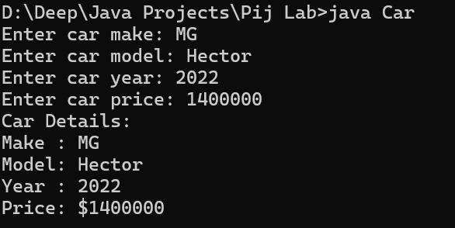

Assignment 2
Solution :-
import java.util.Scanner;

class Calculator {

// First method: takes two ints
public int add(int a, int b) {
return a + b;
}

// Second method: takes three ints
public int add(int a, int b, int c) {
return a + b + c;
}

// Third method: takes two doubles
public double add(double a, double b) {
return a + b;
}

// Main method to demonstrate method overloading
public static void main(String[] args) {
Calculator calc = new Calculator();
Scanner scanner = new Scanner(System.in);

// Demonstrate first method
System.out.print("Enter two integers: ");
int x1 = scanner.nextInt();
int x2 = scanner.nextInt();
System.out.println("Sum of two integers: " + calc.add(x1, x2));

// Demonstrate second method
System.out.print("Enter three integers: ");
int y1 = scanner.nextInt();
int y2 = scanner.nextInt();
int y3 = scanner.nextInt();
System.out.println("Sum of three integers: " + calc.add(y1, y2, y3));

// Demonstrate third method
System.out.print("Enter two doubles: ");
double z1 = scanner.nextDouble();
double z2 = scanner.nextDouble();
System.out.println("Sum of two doubles: " + calc.add(z1, z2));

scanner.close();
}
}
Output :-
